Productivity vs. Procrastination: A Machine Learning Classification Study
Soledad Rodriguez, Jatin Patel, Jean Oussou
CI 345 Machine Learning
Supervised by Dr Julie Zhang
Abstract
In order to understand the relationship between procrastination habits, study behaviors, and productivity levels, we developed this project using machine learning techniques. We selected the Productivity vs Procrastination dataset from Kaggle and converted the continuous productivity score into three categories: Low, Medium, and High to frame the task as a multi-class classification problem. To ensure the data was ready for modeling, we performed Exploratory Data Analysis (EDA), data visualization, and preprocessing steps to examine feature distributions, detect potential issues, and transform categorical variables into numerical form. Three models were then applied: Standard Logistic Regression, Decision Tree, and Random Forest, with hyperparameters optimized using Randomized Search. Their performance was evaluated using accuracy, precision, recall, and F1-score. The tuned Random Forest model achieved a strong overall accuracy of 82% and an impressive 0.93 F1-score on the largest target class, demonstrating that machine learning can successfully reveal meaningful behavioral patterns to predict personal productivity outcomes.
Introduction
Productivity and procrastination significantly influence academic, professional, and personal success. Many individuals struggle with time management and task completion, making it valuable to understand whether productivity levels can be predicted from behavioral patterns.
The objective of this project is to build classification models using the Productivity vs Procrastination dataset from Kaggle. Since the goal is to predict productivity categories from existing data, the problem is well suited to supervised machine learning. This project also provides an opportunity to apply the complete machine learning workflow, including data exploration, preprocessing, model training, hyperparameter tuning, and evaluation.
Dataset Description
The dataset contains behavioral and productivity-related features that may influence overall productivity outcomes. It was selected because of its relevance to student and workplace productivity and because it contains both numerical and categorical variables.
Dataset exploration included:
- Number of samples and features
- Data types of variables
- Target class distribution
- Missing values
- Summary statistics
These checks help determine data quality and suitability for machine learning.
Data Analysis and Visualization
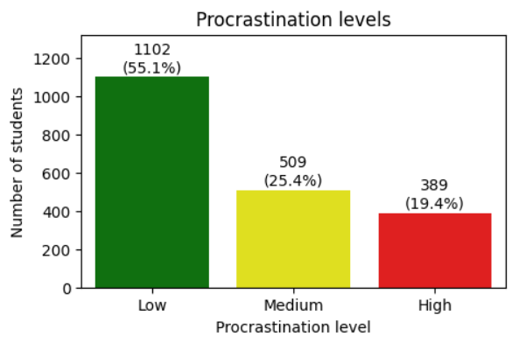
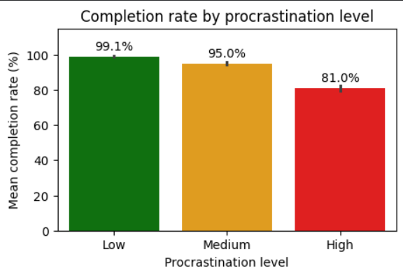
EDA was conducted to understand the dataset before modeling. Numerical features were summarized using descriptive statistics, while categorical variables were analyzed through frequency counts. Missing values were examined and handled where necessary.
The target class distribution was also inspected to identify potential class imbalance, which can affect model performance.
The project includes four visualizations:
- Bar chart of target class distribution
- Histogram of a numerical feature
- Box plot for outlier detection
- Correlation heatmap of numerical variables
These visualizations provide insight into data distribution, outliers, and relationships among variables, supporting preprocessing and model selection decisions.
Preprocessing
To format the raw data for mathematical modeling, the preprocessing was executed following four key transformations:
- Feature Selection: Dropped completely irrelevant attributes.
- Imputation: Handled structural missing data fields.
- Categorical Encoding: Applied Label Encoding or One-Hot Encoding depending on feature cardinality.
- Data Splitting: Partitioned the samples into distinct training and testing matrices.
Models
1. Standard Logistic Regression
Standard Logistic Regression is a fundamental classification algorithm used to model the probability of a categorical dependent variable. For multi-class classification (Low, Medium, High), the multinomial logistic regression extension is used, utilizing the SoftMax function to output a probability distribution across the three classes.
The mathematical formulation for the probability of a class k given a feature vector x is:
$$P\left(Y=k∣x\right)=\frac{e^{β_{k}^{T}x}}{\sum_{j=1}^{K}{e^{β_{j}^{T}x}}}$$Where:
- $k$ = total number of classes (3)
- $β$_{k}= coefficient vector associated with class k
- $x$ = feature vector of behavioral attributes
2. Decision Tree
Decision Tree is a widely used classification algorithm that predicts classes by recursively splitting data based on feature values. It is easy to interpret and can handle both numerical and encoded categorical features. Splitting nodes optimize structural purity via Gini Impurity, Entropy, and Information Gain:
$$\text{Gini }\text{Impurity}=1-\sum_{i=1}^{C}{{\left(p_{i}\right)}^{2}}$$
$$\text{Entropy}=-\sum_{i=1}^{C}{p_{i}}\log_{2}\left(p_{i}\right)$$
$$\text{Information Gain}=\text{Impurity(parent)}-\sum_{v∈\text{children}}{\frac{N_{v}}{N_{\text{parent}}}}\text{Impurity}\left(v\right)$$
Maximum tree depth limits were enforced to mitigate standard overfitting tendencies.
3. Random Forest
To improve generalization, a Random Forest ensemble was constructed. By aggregating a multitude of deep decision trees built on distinct bootstrap data samples, the model determines final classification outcomes via a majority voting mechanism, which drastically curbs variance compared to standalone trees.
Results
The models were validated on a testing subset consisting of 400 samples.
Overall Model Performance Comparison
Model | Overall Accuracy | Macro Avg Precision | Macro Avg Recall | Macro Avg F1-Score
Standard Logistic Regression | 0.86 | 0.84 | 0.83 | 0.83
Decision Tree | 0.77 | 0.73 | 0.72 | 0.72
Random Forest | 0.82 | 0.79 | 0.78 | 0.78

Per-Class Performance Breakdown
Model | Metric | Class 0 (Low) | Class 1 (Medium) | Class 2 (High)
Standard Logistic Regression | Precision  Recall  F1-Score | 0.85  0.77  0.81 | 0.94  0.94  0.94 | 0.73  0.77  0.75
Decision Tree | Precision  Recall  F1-Score | 0.71  0.60  0.65 | 0.90  0.88  0.89 | 0.58  0.67  0.62
Random Forest | Precision  Recall  F1-Score | 0.80  0.68  0.74 | 0.93  0.93  0.93 | 0.66  0.73  0.69

Discussion
The experimental results demonstrate notable discrepancies across the selected classification architectures. Standard Logistic Regression emerged as the optimal classifier, securing the highest global accuracy (86%) and a weighted macro F1-score of 0.83. This implies that the behavioral log features mapping procrastination to productivity categories maintain a predominantly linear decision boundary, allowing a parametric logistical model to generalize better than non-parametric structures.
Class 1 (Medium productivity) held the highest support with 215 samples, allowing all models to yield exceptional metrics peaking at a 0.94 F1-score under Logistic Regression. Conversely, Class 2 (High productivity) and Class 0 (Low productivity) presented lower baseline performance across the board due to structural representation limits. Notably, the single Decision Tree suffered significantly from variance and overfitting, collapsing to an accuracy of 77% and a weak Class 2 precision of 0.58.
While the ensemble approach of the Random Forest stabilized the tree split errors (improving overall accuracy to 82%), it failed to outperform Standard Logistic Regression. This confirms that adding ensemble complexity does not always yield superior results over cleaner, linear classification models when managing heavily binned behavioral indices.
Conclusion
This study applied predictive classification architectures to the Productivity vs Procrastination dataset. Counter to standard machine learning assumptions regarding non-linear algorithms, the simpler Standard Logistic Regression framework outperformed both the single Decision Tree and the Random Forest ensemble. The results show that distinct human productivity categories can be effectively mathematically binned and modeled, and highlights the rule that model architecture selection must be driven strictly by the geometric relationships inherent to the underlying dataset.
References
- Kaggle. Productivity vs Procrastination Dataset.
- Scikit-learn Documentation. Logistic Regression Classifier.
- Scikit-learn Documentation. Decision Tree Classifier.
- Scikit-learn Documentation. Random Forest Classifier.
- Géron, A. Hands-On Machine Learning with Scikit-Learn, Keras, and TensorFlow. O'Reilly Media.
- James, G., Witten, D., Hastie, T., & Tibshirani, R. An Introduction to Statistical Learning. StatLearning Website.

